

Faculty oF information AND COMMUNICATION technology
DCOMP204 – WEB DESIGN 1
Title : Sierra Leone Football Agency
Issue Date : Week 8
Due Date : Week 11
Lecturer : Cornelious M Grant
Year/Semester : 2/1
Class : BIT 1202F
NO. | Name | Surname | ID | SIGN
1. | Mitchelle Nyakeh | Kamanda | 905005508
2. | Theresa | Conteh | 905005181
3. | Isatu | Bah | 905005498
4. | Mariama Marian | Turay | 905005211
Academic Honesty Policy Statement
We, hereby attest that contents of this attachment are my own work. Referenced works, articles, art, programs, papers or parts thereof are acknowledged at the end of this paper. This includes data excerpted from CD-ROMs, the Internet, other private networks, and other people’s disk of the computer system.

Submitting Person’s Signature: Date: 30th NOVEMBER 2025
(If submission is for a group work, all students’ names MUST appear above and put down their signatures here)

LECTURER’S COMMMENTS/GRADE: | for office use only upon receive  Remark  DATE :  TIME :  RECEIVER’S NAME :

HOME PAGE SCREENSHOT
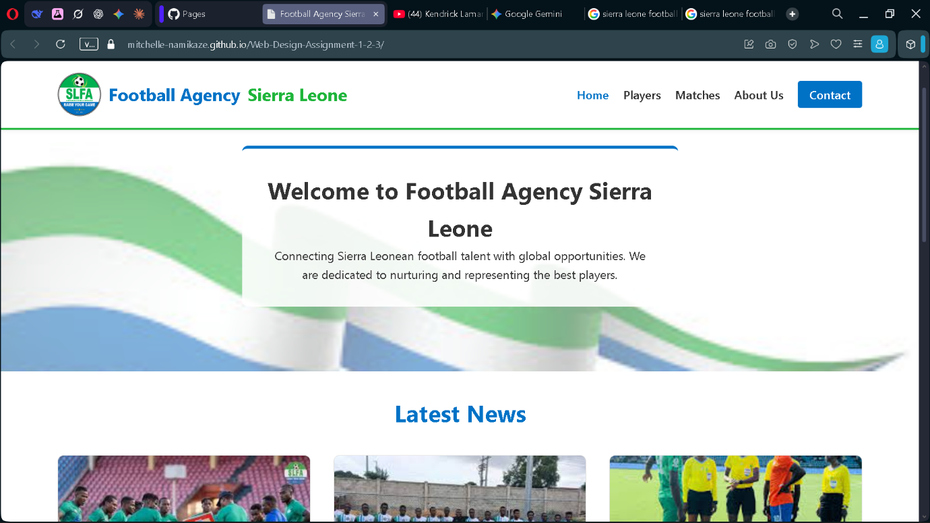

PLAYERS PAGE SCREENSHOT

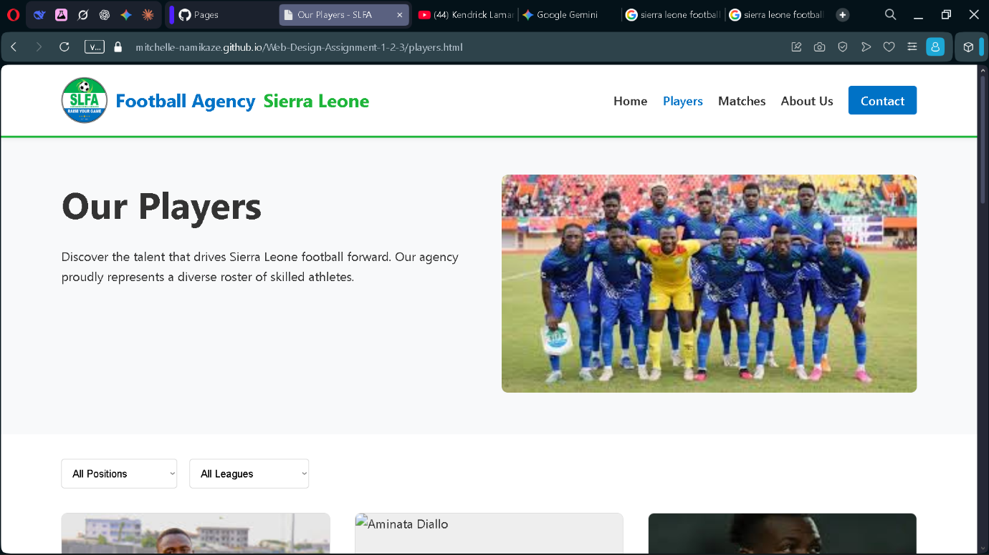

MATCHES PAGE SCREENSHOT

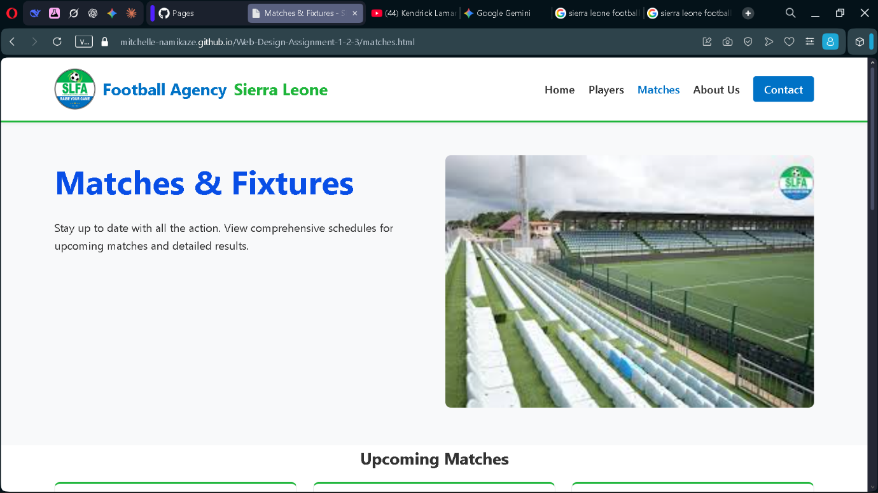

ABOUT US PAGE SCREENSHOT

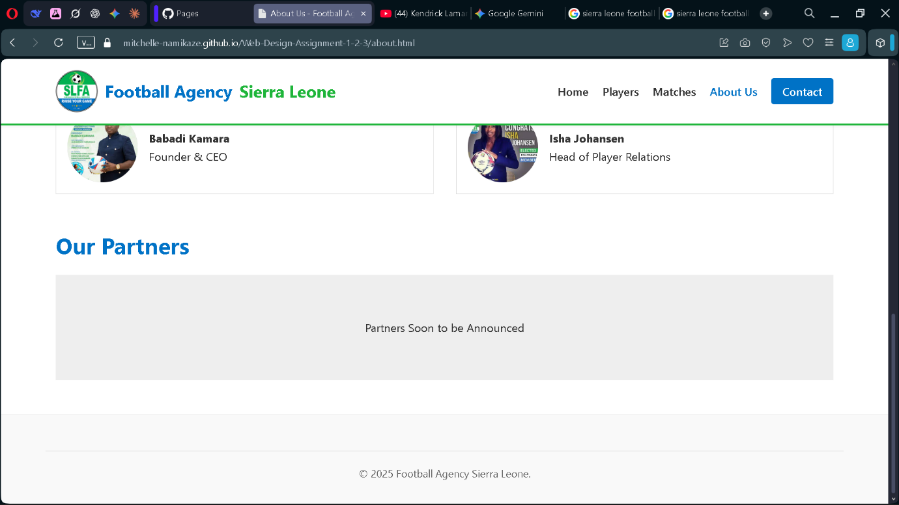

CONTACT US PAGE SCREENSHOT

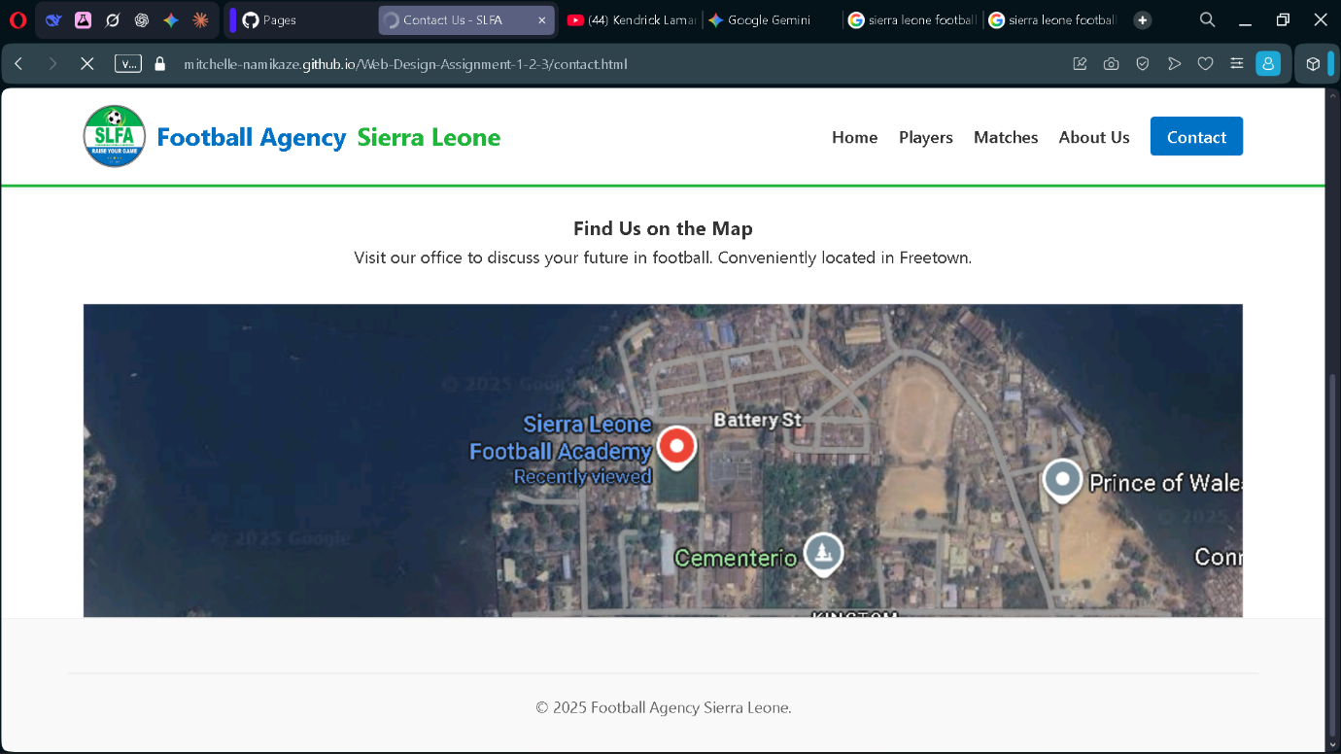

HOME PAGE WIREFRAME

PLAYERS PAGE WIREFRAME

MATCHES PAGE WIREFRAME

ABOUT US PAGE WIREFRAME

CONTACT US PAGE WIREFRAME

